- In Cisco Packet Tracer, create two separate networks (representing two branch offices) using two routers and configure basic IP addressing so that each network can ping its own devices.
Answer
1. Create two separate branch networks
We will create two branch offices using two routers, two switches, and two PCs.
Network topology
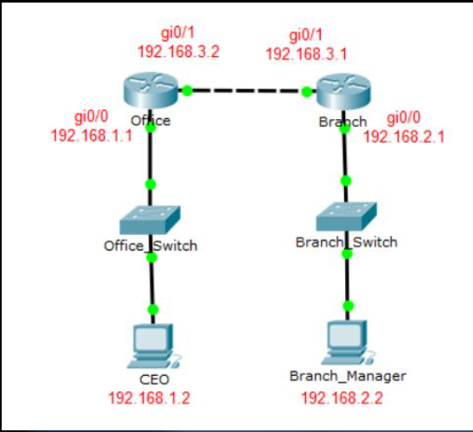
Solved Using Packet Tracer and the topology shown above, | Chegg.com
chegg.com
Network IP addressing
Device | Interface | IP address | Subnet mask
Router 1 | G0/0 | 192.168.1.1 | 255.255.255.0
Router 1 | G0/1 | 10.0.0.1 | 255.255.255.252
Router 2 | G0/0 | 192.168.2.1 | 255.255.255.0
Router 2 | G0/1 | 10.0.0.2 | 255.255.255.252
PC1 | FastEthernet | 192.168.1.10 | 255.255.255.0
PC2 | FastEthernet | 192.168.2.10 | 255.255.255.0
Default gateways:
- PC1: 192.168.1.1
- PC2: 192.168.2.1
Router 1 configuration
enable
configure terminal

hostname R1

interface gigabitEthernet 0/0
ip address 192.168.1.1 255.255.255.0
no shutdown
exit

interface gigabitEthernet 0/1
ip address 10.0.0.1 255.255.255.252
no shutdown
exit

end
write memory
Router 2 configuration
enable
configure terminal

hostname R2

interface gigabitEthernet 0/0
ip address 192.168.2.1 255.255.255.0
no shutdown
exit

interface gigabitEthernet 0/1
ip address 10.0.0.2 255.255.255.252
no shutdown
exit

end
write memory
Testing: Open PC1's Command Prompt and run:
ping 192.168.1.1
Open PC2's Command Prompt and run:
ping 192.168.2.1
Both PCs should successfully ping their own branch routers.

- Configure a basic site-to-site VPN between the two routers in Packet Tracer using GRE tunnel interfaces and assign tunnel IP addresses so that PCs from one branch can ping PCs in the other branch.<br><br><em><strong>Hint:</strong> Use the 'interface tunnel' command on both routers and set the tunnel source and destination to the routers' public-facing interfaces.</em>
Answer
Configure Site-to-Site VPN using GRE Tunnel
A Site-to-Site VPN connects two branch office networks through a secure connection over a public network.
GRE (Generic Routing Encapsulation) creates a virtual tunnel between two routers. 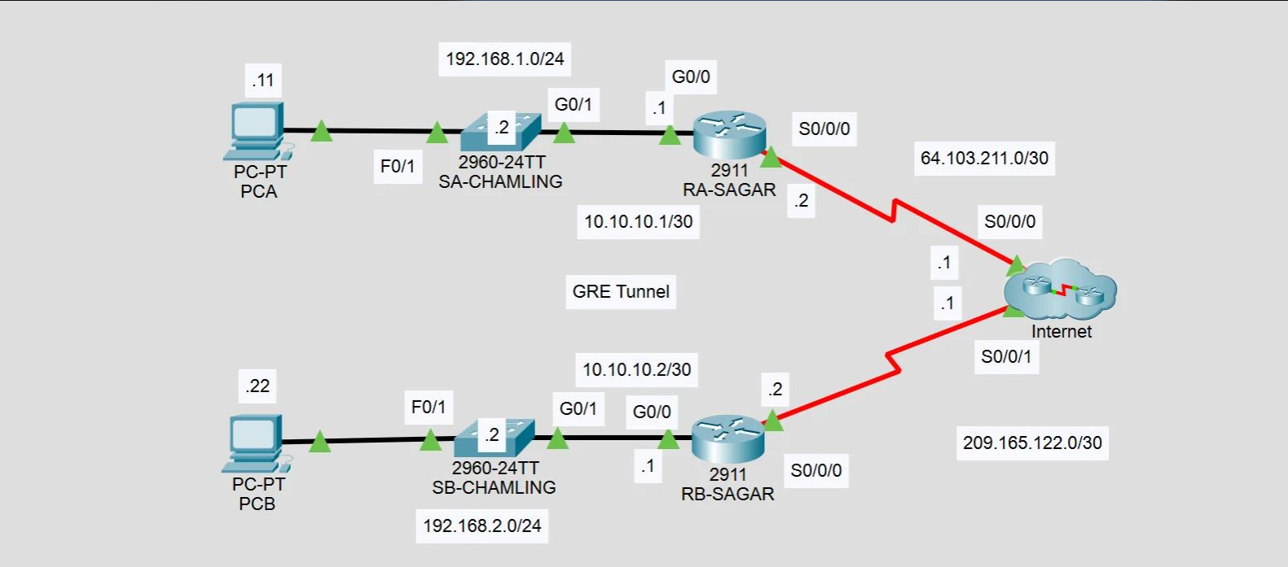

Configuring GRE Tunnel using Cisco Packet Tracer | Sagar Chamling's Blogging Site
sagarchamling.com
GRE tunnel IP addressing
Device | Tunnel interface | IP address
Router 1 | Tunnel 0 | 172.16.0.1/30
Router 2 | Tunnel 0 | 172.16.0.2/30
Router 1 GRE configuration
enable
configure terminal

interface tunnel 0
ip address 172.16.0.1 255.255.255.252
tunnel source gigabitEthernet 0/1
tunnel destination 10.0.0.2
no shutdown
exit

ip route 192.168.2.0 255.255.255.0 172.16.0.2

end
write memory
Router 2 GRE configuration
enable
configure terminal

interface tunnel 0
ip address 172.16.0.2 255.255.255.252
tunnel source gigabitEthernet 0/1
tunnel destination 10.0.0.1
no shutdown
exit

ip route 192.168.1.0 255.255.255.0 172.16.0.1

end
write memory
Testing the VPN connection
From PC1, open Command Prompt:
ping 192.168.2.10
From PC2:
ping 192.168.1.10
If the configuration is correct, both PCs should communicate across the GRE tunnel.
Expected result
Branch 1 and Branch 2 can communicate through the tunnel.
Important: GRE by itself does not encrypt data. It creates a tunnel but does not provide confidentiality. A true encrypted site-to-site VPN requires GRE over IPsec or an IPsec VPN configuration.

- Simulate a remote access VPN scenario in Packet Tracer by configuring a VPN client PC to connect securely to one of the branch routers using the built-in VPN client feature.<br><br><em><strong>Hint:</strong> Use the VPN tab on the PC and set the correct server IP, username, and password.</em>
Answer
Configure Remote Access VPN in Packet Tracer
A Remote Access VPN allows an individual user to connect securely to a company's private network from a remote location.
For this practical, use:
- One remote PC (VPN client).
- One VPN server (Cisco ASA 5505 or a supported VPN server device).
- One branch LAN.
Solved: Remote client can't access LAN server via VPN - Cisco Community
community.cisco.com
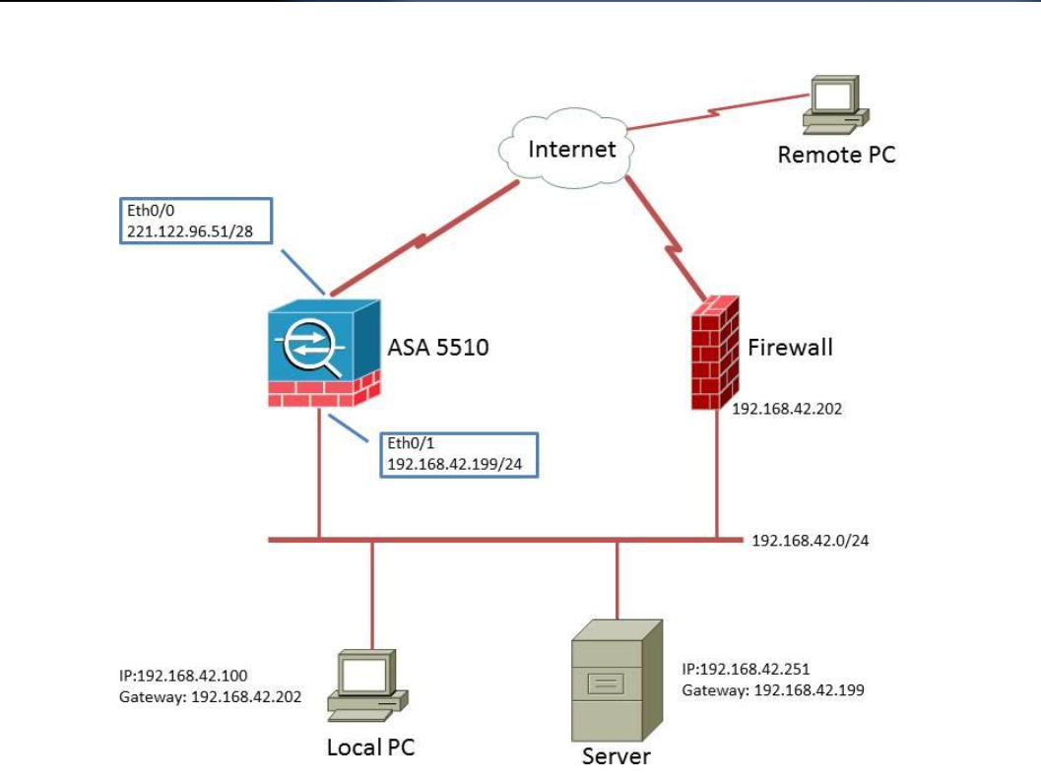
Step 1: Configure the VPN client PC
- Open Cisco Packet Tracer.
- Select the remote PC.
- Click the Desktop tab.
- Select VPN.
- Enter the VPN details.
Example settings:
VPN field | Value
Group Name | VPNGROUP
Group Key | 123
Host IP (Server IP) | 192.168.2.1
Username | student
Password | cisco123
- Click Connect.
- Click OK if a confirmation window appears.
Configuring PCs
tutorials.ptnetacad.net
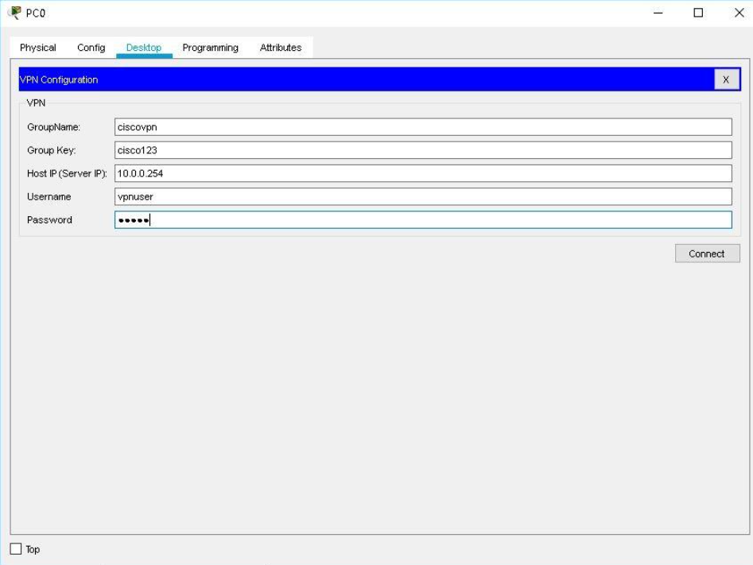
Step 2: Configure the VPN server
The VPN server must be configured with matching group information and user authentication before the client can connect.
For a Packet Tracer activity using a supported ASA VPN server, configure its remote-access VPN settings to match:
- Group name: VPNGROUP
- Group key: 123
- Username: student
- Password: cisco123
The VPN server also needs an address pool for remote clients and access to the branch LAN.
Important practical note: The PC's VPN tab is a client interface, not a VPN server configuration tool. The server-side configuration must be completed separately. In Packet Tracer, use an ASA/server model and VPN options supported by your installed version. The exact server configuration varies by device and Packet Tracer version. Cisco's Packet Tracer VPN exercise demonstrates this PC VPN-tab workflow.
Configuring VPN Transport Mode+1
Step 3: Test the Remote Access VPN
After the VPN connection is established:
- Open the PC's Command Prompt.
- Enter:
ipconfig
- Check whether a VPN-assigned IP address appears.
- Ping a device in the private branch network.
Example:
ping 192.168.2.10
Expected result
The remote PC should be able to access the authorized branch network through the VPN.

- List and explain the main differences between site-to-site VPN and remote access VPN based on your Packet Tracer configurations, including at least two advantages and disadvantages of each approach.
Answer
Differences between Site-to-Site VPN and Remote Access VPN
Basis | Site-to-Site VPN | Remote Access VPN
Connection | Connects two office networks | Connects an individual user to an office network
Users | Entire branch network | Individual employees
Configuration | Configured on both VPN gateways | Configured on VPN server and client
Authentication | Usually gateway authentication | User authentication and sometimes certificates
Example | Ahmedabad office to Bangalore office | Employee working from home
Management | Managed by network administrators | Managed by administrators and individual users
Usage | Permanent branch connectivity | Temporary or individual remote connectivity
Advantages and disadvantages
A. Site-to-Site VPN
Advantages:
- Connects two different office networks securely.
- Employees can share resources between branches.
- Once configured, communication can happen automatically.
Disadvantages:
- Requires configuration on both routers or VPN gateways.
- Troubleshooting can be difficult.
- Requires compatible network equipment and internet connectivity.
B. Remote Access VPN
Advantages:
- Employees can access office resources from anywhere.
- Supports work-from-home facilities.
- Individual users can be authenticated using usernames and passwords.
Disadvantages:
- Requires VPN client configuration.
- Too many simultaneous users can affect network performance.
- Weak passwords or stolen credentials can create security risks.
Real-world examples
- Site-to-Site VPN: Connecting two company offices in Ahmedabad and Bangalore.
- Remote Access VPN: An employee in Jaipur accessing the company's office network from home.

  - Document and submit the step-by-step configuration commands you used to set up the site-to-site VPN in Packet Tracer, including interface, tunnel, and routing commands.
Answer
Step-by-Step Site-to-Site VPN Configuration Commands
The following commands can be included in your practical file or assignment.
Step 1: Configure Router 1 interfaces
enable
configure terminal
hostname R1

interface gigabitEthernet 0/0
ip address 192.168.1.1 255.255.255.0
no shutdown
exit

interface gigabitEthernet 0/1
ip address 10.0.0.1 255.255.255.252
no shutdown
exit
Step 2: Configure Router 2 interfaces
enable
configure terminal
hostname R2

interface gigabitEthernet 0/0
ip address 192.168.2.1 255.255.255.0
no shutdown
exit

interface gigabitEthernet 0/1
ip address 10.0.0.2 255.255.255.252
no shutdown
exit
Step 3: Configure GRE Tunnel on Router 1
interface tunnel 0
ip address 172.16.0.1 255.255.255.252
tunnel source gigabitEthernet 0/1
tunnel destination 10.0.0.2
no shutdown
exit
Step 4: Configure GRE Tunnel on Router 2
interface tunnel 0
ip address 172.16.0.2 255.255.255.252
tunnel source gigabitEthernet 0/1
tunnel destination 10.0.0.1
no shutdown
exit
Step 5: Configure Static Routing
Router 1:
ip route 192.168.2.0 255.255.255.0 172.16.0.2
Router 2:
ip route 192.168.1.0 255.255.255.0 172.16.0.1
Step 6: Save the configuration
On both routers:
end
write memory
Step 7: Verify the configuration
Use these commands:
Command | Purpose
show ip interface brief | Check interface status
show interfaces tunnel 0 | Check GRE tunnel status
show ip route | Check routing table
show running-config | View complete configuration
ping 172.16.0.2 | Test tunnel connectivity from R1
ping 192.168.2.10 | Test remote PC connectivity from PC1
Expected results:
Branch 1 LAN
Connected
Branch 2 LAN
Connected
GRE Tunnel
Up / Up
PC1 to PC2 Ping
Successful
Note: These are expected results, not actual test results. Interface names may differ depending on your router model. Also, these GRE commands configure tunneling, not IPsec encryption.

